1. Dereferencing a possibly null pointer.
#include <stdio.h>
#include <stdbool.h>

char nullDeref(char *s)
{
if (s == NULL)
{
return '\0';
}
return *s;
}

int main()
{
nullDeref(NULL);
return 0;
}

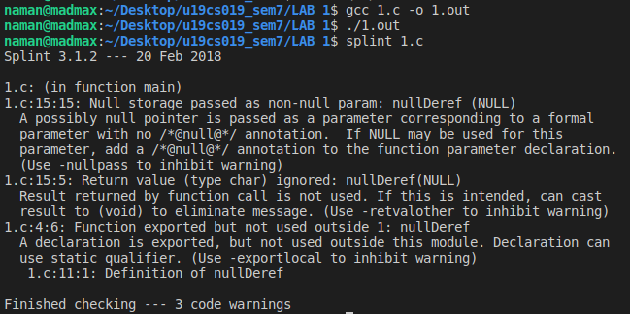
2. Using possibly undefined storage or returning storage that is not properly defined.

#include <stdio.h>
#include <stdbool.h>

extern void setVal(int *x);
extern int getVal(int *x);

int check(int *x, int ch)
{
if (ch == 1)
{
return *x;
}
else if (ch == 2)
{
return getVal(x);
}
else
{
setVal(x);
return *x;
}
}

int main()
{
int *x, ch = 4;
printf("%d", check(x, ch));
return 0;
}

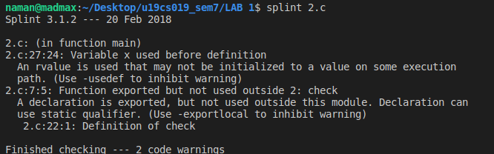
3. Type mismatches, with greater precision and flexibility than provided by C compilers
#include <stdio.h>
#include <stdbool.h>

int main()
{
int i = 0;
if (i == true)
{
printf("hi");
}
return 0;
}

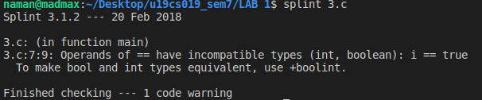
4. Violations of information hiding.
#include <stdio.h>
#include <string.h>
#include <stdbool.h>
#include <string.h>
#include"str.h"

// typedef char *str;

bool isPalindrome(str s)
{
char *current = (char *)s;
int i, len = (int)strlen(s);
for (i = 0; i <= (len + 1) / 2; i++)
{
if (current[i] != s[len - i - 1])
return false;
}
return true;
}
bool callPal(void)
{
return (isPalindrome("bob"));
}
int main()
{
// callPal();
return 0;
}
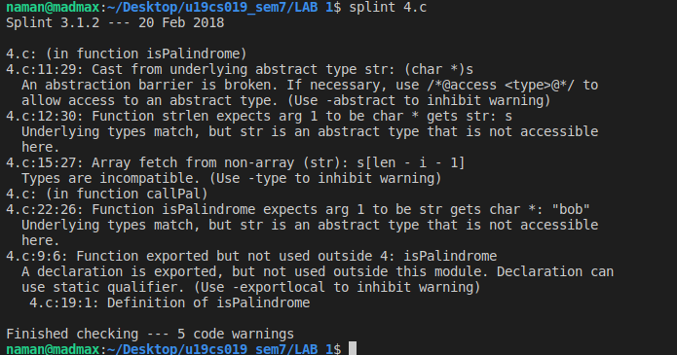
5. Memory management errors including uses of dangling references and memory leaks.
#include <stdio.h>
#include <stdlib.h>

extern int *glob;
int *glob;
int *f(int *x, int *y, int *z)
{
int *m = (int *)malloc(sizeof(int));
glob = y; // Memory leak
free(x);
*m = *x; // Use after free
return z; // Memory leak detected
}

int main()
{
return 0;
}
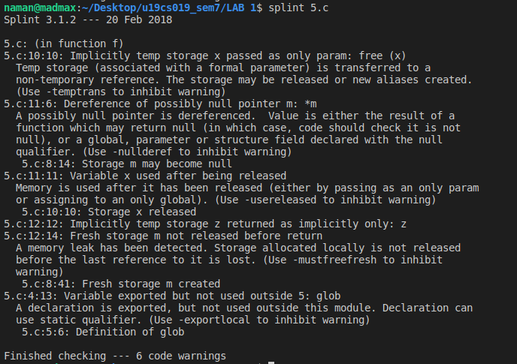
6. Dangerous aliasing.
#include <stdio.h>
#include <stdbool.h>

int da(int *ptr1, int *ptr2)
{
*ptr1 = 10;
*ptr2 = 11;
return *ptr1;
}

int main()
{
int a = 10,b=1;
da(&a, &b);
return 0;
}

